 | STMIK Muhammadiyah Paguyangan Brebes  Jl. Raya Paguyangan, Desa Paguyangan,  Kec. Paguyangan, Kab. Brebes, Kode Pos 52276  Telp : (0289) 440 3691  PROGRAM STUDI TEKNIK INFORMATIKA | 

LAPORAN PRAKTIKUMUM PEMROGRAMAN DESKTOP
MENGGUNAKAN VISUAL BASIC .NET

Nama : ....................................................
NIM : ....................................................
Prodi : ....................................................
Semester : ....................................................

- Deskripsi Visual Basic .NET
.............................................................................................................................................................
.............................................................................................................................................................
.............................................................................................................................................................
.............................................................................................................................................................
.............................................................................................................................................................
.............................................................................................................................................................
.............................................................................................................................................................
.............................................................................................................................................................
.............................................................................................................................................................
.............................................................................................................................................................
.............................................................................................................................................................
.............................................................................................................................................................
.............................................................................................................................................................
.............................................................................................................................................................
.............................................................................................................................................................
.............................................................................................................................................................
.............................................................................................................................................................
.............................................................................................................................................................
- PRAKTIKUM 1
- Judul
Membuat User Form ID Mahasiswa
- Tujuan
- Memahami dan mengenal Form dan Objek Kontrol;
- Dapat membuat aplikasi sederhana dengan menggunakan form dan objek kontrol khususnya ComboBox
- Dapat menampilkan icon pada Dialog Pesan atau MessageBox
- Teori
ComboBox adalah ......................................................................................................................
.....................................................................................................................................................
.....................................................................................................................................................
Dialog Pesan adalah ......................................................................................................................
.....................................................................................................................................................
.....................................................................................................................................................
- Pengaturan Properti pada Kontrol yang Digunakan
No | Object | Property | Nilai
1 | Form 1 | Name  Text | frmcoba  Form ID Mahasiswa
2 | Label 1 | Text | Nama
3 | Label 2 | Text | Jenis Kelamin
4 | Label 3 | Text | Program Studi
5 | TextBox1 | Name  Text | txtnama  (dikosongi)
6 | ComboBox1 | Name  Items  DropDownStyle | cbojeniskelamin  -Laki-Laki  -Perempuan  DropDownList
7 | ComboBox2 | Name  Items  Dropdownstyle | cboprodi  - Teknik Informatika  - Sistem Informasi  Dropdownlist
8 | Button1 | Name  Text | btntampilkan  Tampilkan Pesan

- Tampilan Desain Form

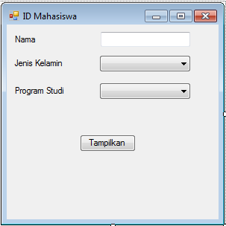
- Kode Program
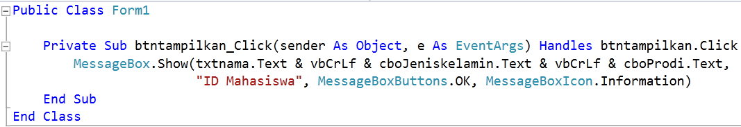
- Output
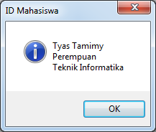
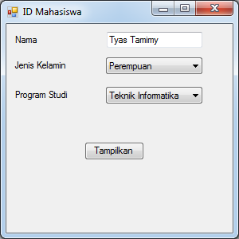

- PRAKTIKUM 2
- Judul
Membuat Program Hitung Bilangan
- Tujuan
- Teori
- Pengaturan Properti pada Kontrol yang Digunakan
- Tampilan Desain Form
- Kode Program
- Output

- PRAKTIKUM 3
- Judul
Membuat Program Simpan Harga dan Detail Produk
- Tujuan
- Teori
- Pengaturan Properti pada Kontrol yang Digunakan
- Tampilan Desain Form
- Kode Program
- Output

- PRAKTIKUM 4
- Judul
Membuat Program Opsi Pilihan dengan CheckBox
- Tujuan
- Teori
- Pengaturan Properti pada Kontrol yang Digunakan
- Tampilan Desain Form
- Kode Program
- Output

- PRAKTIKUM 5
- Judul
Membuat Program Opsi Pilihan dengan RadioButton dan Warna Form
- Tujuan
- Teori
- Pengaturan Properti pada Kontrol yang Digunakan
- Tampilan Desain Form
- Kode Program
- Output

- PRAKTIKUM 6
- Judul
Membuat Program dengan ListBox
- Tujuan
- Teori
- Pengaturan Properti pada Kontrol yang Digunakan
- Tampilan Desain Form
- Kode Program
- Output

- PRAKTIKUM 7
- Judul
Membuat Program Jenis dan Ukuran Font
- Tujuan
- Teori
- Pengaturan Properti pada Kontrol yang Digunakan
- Tampilan Desain Form
- Kode Program
- Output

- PRAKTIKUM 8
- Judul
Membuat Program dengan ProgressBar
- Tujuan
- Teori
- Pengaturan Properti pada Kontrol yang Digunakan
- Tampilan Desain Form
- Kode Program
- Output

- PRAKTIKUM 9
- Judul
Membuat Web Browser
- Tujuan
- Teori
- Pengaturan Properti pada Kontrol yang Digunakan
- Tampilan Desain Form
- Kode Program
- Output

- PRAKTIKUM 10
- Judul
Membuat Program Menghitung Usia
- Tujuan
- Teori
- Pengaturan Properti pada Kontrol yang Digunakan
- Tampilan Desain Form
- Kode Program
- Output

